**Name: Ammaar Ahmad**

**Roll No: 1801CS08**

1. **Instruction loaded at 0000 ROM**

**MIPS code Machine Code**

**add** $s0, $0, $0 0x00008020

**add** $s1, $0, $0 0x00008820

**addi** $t0, $0, 10 0x2008000A

loop:

**slt** $t1, $s0, $t0 0x0208482A

**beq** $t1, $0, done 0x11200003

**add** $s1, $s1, $s0 0x02308820

**addi** $s0, $s0, 1 0x22100001

**j** loop 0x08000003

done:

Initially there was an error in control decoder.

This instruction **addi** $t0, $0, 10 was doing subtraction instead of addition. Opcode: 001000, ALU: 0101

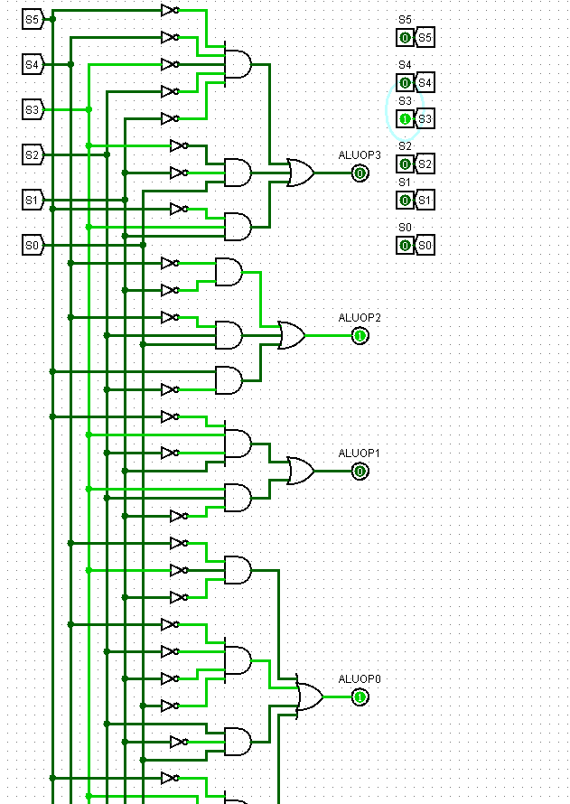

After rectification, it performs correctly Opcode: 001000

ALU: 0100

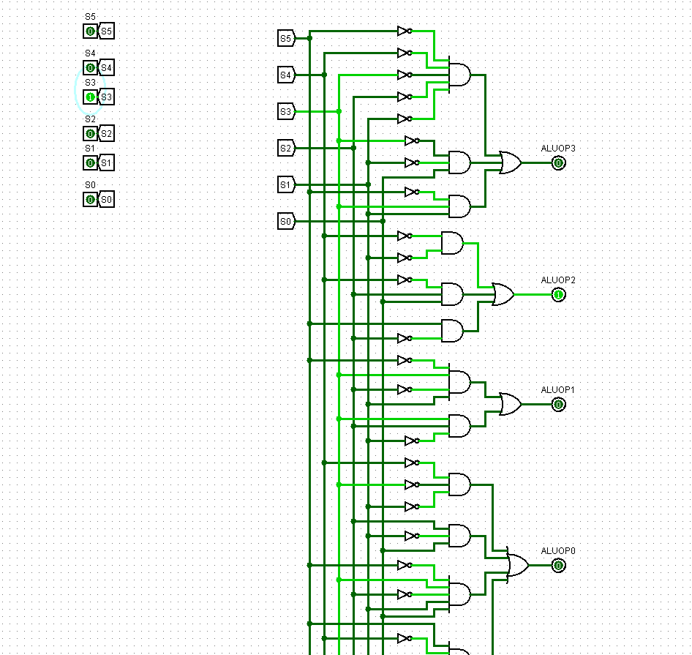

This program was adding whole numbers<10

Output $t0=10(constant), $t1=0(equality) $s0=10 $s1=45=2D(Hex) – Final Answer

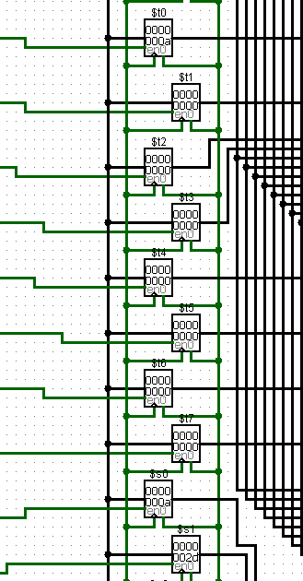

1. Calculating Cycles in each type of processor

**MIPS code Machine Code No. of cycles**

**add** $s0, $0, $0 0x00008020 1

**add** $s1, $0, $0 0x00008820 1

**addi** $t0, $0, 10 0x2008000A 1

loop:

**slt** $t1, $s0, $t0 0x0208482A 11

**beq** $t1, $0, done 0x11200003 11

**add** $s1, $s1, $s0 0x02308820 10

**addi** $s0, $s0, 1 0x22100001 10

**j** loop 0x08000003 10

done:

No. of instructions: 55

No. of cycles in Single cycle processor: 55

CPI for Single cycle processor: 1

**MIPS code Machine Code No. of cycles**

**add** $s0, $0, $0 0x00008020 1*4=4

**add** $s1, $0, $0 0x00008820 1*4=4

**addi** $t0, $0, 10 0x2008000A 1*4=4

loop:

**slt** $t1, $s0, $t0 0x0208482A 11*4=44

**beq** $t1, $0, done 0x11200003 11*3=33

**add** $s1, $s1, $s0 0x02308820 10*4=40

**addi** $s0, $s0, 1 0x22100001 10*4=40

**j** loop 0x08000003 10*3=30

No. of cycles in Multi cycle processor: 199

CPI for Multi cycle processor: 199/55=3.6(approx)

In Pipelined processor, beq instruction requires control hazard and is rectified by stalling until new PC is calculated (3 cycles)

**MIPS code Machine Code No. of cycles**

**add** $s0, $0, $0 0x00008020 1*1=1

**add** $s1, $0, $0 0x00008820 1*1=1

**addi** $t0, $0, 10 0x2008000A 1*1=1

loop:

**slt** $t1, $s0, $t0 0x0208482A 11*1=11

**beq** $t1, $0, done 0x11200003 11*4=44

**add** $s1, $s1, $s0 0x02308820 10*1=10

**addi** $s0, $s0, 1 0x22100001 10*1=10

**j** loop 0x08000003 10*5=50

beq instruction stalls for 3 more cycle so 4 cycles per beq

j (jump) instruction waits for all instructions to complete that is stall for 4 cycles using total 5 cycles per jump instruction

Each instruction can take maximum 5 cycles for complete process but beq has no write back instructions to execute hence it completes in 4 cycles.

No. of cycles in Pipelined processor: 128

CPI for Multi cycle processor: 128/55=2.3(approx)